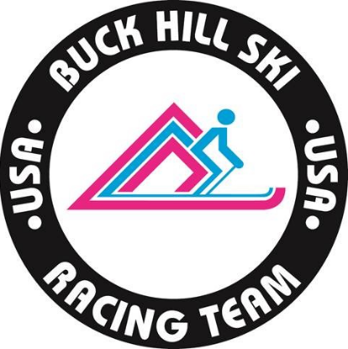

Dear Buck Hill Athletes and Parents,
Winter Park registration is officially open. See the attached brochure for full camp details and following the link below to register for camp. Registration will open to non-members beginning on September 25th.
CLICK HERE TO REGISTER
Pace
We have an incredible group of pace athletes this year. Westminster College men’s and women’s alpine teams will be attending both sessions of camp to train, demonstrate and coach athletes at camp. They will also be assisting with coaching at video sessions.
Lift Passes
Lift passes are not included in the price of camp. Follow the below link below to purchase your Winter Park training pass. Ikon passes WILL work if Winter Park is open to the public. Barring any unforeseen circumstances Ikon passes will work for both sessions of camp.
Winter Park Lift Passes
Lodging
We encourage members to take advantage of our group lodging rates through Winter Park Lodging Company. Follow the link and contact numbers below to book your rooms. Tuning space and video sessions will all take place at the Vintage Hotel. Group code for booking is 3HA8UR.
Booking Vintage hotel can be done by clicking here.
Booking Zephyr Mountain Lodge or Fraser Crossing/Founders Pointe Call 970.726.8400.

Additional camp details are in the Winter Park Camp brochure.

Dave Ziemer
dziemer@buckhill.com

